Medical Education Assessment for 21st Century Health Systems

AMC Workshop

Workshop Report
1 November 2017

Contents

Medical Education Assessment for 21st Century Health Systems Workshop 5
Details 5
Workshop purpose 5
Workshop themes 6
Schedule 7
Participants 8
Summary of discussion questions 15
Presenters 17
Setting the Scene 18
Assessment Standards at the AMC 18
AMC Assessment Innovation 19
At a Glance: Recent Trends in Assessment 20
Programmatic Assessment and the Medical Continuum 22
Programmatic Assessment – What Problems are we Solving? 31
Focus on Implementation 49
Where to Next for Assessment? 52
Next Steps 54
Further Reading 55

Medical Education Assessment for 21st Century Health Systems Workshop

Details
Date | Wednesday 1 November 2017
Time | 09.30 – 16.15
Location | Pan Pacific Hotel, Melbourne
Contact | Accreditation team on phone +61 02 6270 9725 or  email accreditation@amc.org.au

Workshop purpose
In this workshop we:
- Fundamentals of Programmatic Assessment Gained an understanding of the fundamentals of Programmatic Assessment
- Common problems and innovations Reviewed common problems and innovations in assessment across the medical continuum and at the AMC to understand alignment with programmatic assessment concepts and AMC standards
- Good ideas and burning questions Had opportunities to share good ideas and ask burning questions about assessment from experts and peers
- Practical Strategies Gained practical strategies for how to design and implement a programmatic approach to assessment
- Implementation – case studies Shared information about a range of pilots of National and International innovations in assessment across the medical continuum and at the AMC relating to programmatic assessment
- Reflections on improving own training program and next steps Reflected on how to further improve assessment practices in your own training program and future directions for review of AMC standards on assessment

Workshop themes
Throughout this workshop we explored the following themes of assessment:
- Fit for Purpose: ensuring that methods and approaches focus on best practice medical education evidence and assess skills and behaviours relevant to 21 century health needs and systems.
- Feedback and culture: improving feedback and learning cultures to ensure learners are empowered and supported.
- Discrimination of performance: improving methods of identifying good and poor performance through longitudinal assessment systems. This is a shift from more traditional norm referenced assessments, which are more focused on comparing candidates against each other rather than of their achievement of standards, and assessment for learning methods to ensure each individual doctor is the best they can be.
- Benchmarking, technology enabled reporting and research and evaluation: ensuring equity in decision making, and feasibility and quality of innovation of assessments through benchmarking assessment methods across the continuum, conducting research and evaluation and enabling decision making with use of technologies for monitoring progression and quality programs.
- Implementation: ensuring high quality, feasibility, sustainability, cost effectiveness, and acceptability of assessment systems. Successful implementation includes:
- robust communication and management of change process
- effective governance and champion model of ongoing support and leadership
- operational management to ensure smooth delivery of the assessment
- supervisor/assessor training to ensure consistency of decision making and quality of feedback
- plans for evaluation and quality control to inform future quality improvements to assessments
- ongoing resource and stakeholder management to ensure continuity of support.

Schedule

8.30 | Morning tea on arrival
9.30 | Forum open
9.30 | Setting the Scene
 | Welcome from President
 | Presentation: Setting the Scene – Assessment at the AMC
9.50 | Programmatic Assessment and the Medical Continuum
Presentation: Programmatic Assessment Fundamentals – history of assessment from psychometrics to progression and subjectivity.
Q & A
 | Group Activity 1 and Plenary Discussion: Where are we with programmatic assessment concepts – summary of current state
11.00 | Programmatic Assessment – What Problems are we Solving?
 | Group Activity 2: Good Ideas and Burning Questions
11.30 | Morning Tea Break
 | Q and A Good Ideas and Burning Questions (cont.)
 | Presentation: Problems Assessment Systems are Solving
13.10 | Lunch Break
14.00 | Focus on Implementation
Group Activity: Five Case Studies of successful implementation of Programmatic Assessment concepts
(Participants attend 3 case studies – one in each of the three sessions – see back of name badge for details)
 | Tea/Coffee Available
15.20 | Where to Next for Assessment?
 | Panel Discussion: Next Steps in Medical Education Assessment for Health Systems of the 21 Century
 | Next steps
16.15 | Meeting close

Participants
Facilitators and Presenters | Institution | Role
Professor Cees van der Vleuten | School of Health Professions Education, University of Maastricht, Netherlands | Scientific Director
Professor Lambert Schuwirth | Flinders University | Strategic Professor for Medical Education and Director of the Flinders University Prideaux Centre for Research in Health Professions Education
Ms Christine Cook | GPEx and ModMed | Chief Executive Officer
Professor Kichu Nair AM | School of Medicine and Public Health / HNE Local Health District | Professor of Medicine and Deputy Dean (Clinical Affairs) / Director, Centre for Medical Professional Development
Dr Beth Mulligan | Launceston General Hospital | Director of Clinical Training
Professor Liz Molloy | Melbourne Medical School, the University of Melbourne | Professor in Work Integrated Learning in the Department of Medical Education
Professor Pete Ellis | The University of Otago | Head, Department of Psychological Medicine
Professor Liz Farmer | AMC Prevocational Standards Accreditation Committee | Chair
Professor David Prideaux | Prideaux Centre for Research in Health Professions Education, Flinders University | Director and Chair of Assessment Committee, AMC

Participant | AMC Committee | Role
Professor Jill Sewell | AMC | President
Associate Professor Kim Rooney | AMC | Director
Mr Ian Civil | SEAC | Committee member
Ms Jacqui Gibson | SEAC | Committee member
Mrs Helen Maxwell-Wright | SEAC | Committee member
Mr Rob Thomas | MedSAC | Committee member
Participant | Health Department | Role
Dr Linda MacPherson | NSW Ministry of Health | Medical Advisor
Dr June Song | Department of Health and Human Services - Tasmanian Health Service, Southern Region | Director of Medical Education & Training
Ms Megan Crawford | Queensland Health, Prevention Division | Director - Office of the Chief Medical Officer,
Ms Rachel Hoffman |  | Manager - Office of the Chief Medical Officer
Dr Jeanette Young |  | Chief Health Officer & DDG

Participant | Specialist College | Role
Mrs Anna Kaider | Australasian College for Emergency Medicine | Education Development Projects Lead
Mr Bernhard Liedtke |  | Education Systems Development Manager
Dr David Burdon-Jones | Australasian College of Dermatologists | Chief Examiner
Dr Catherine Drummond |  | Chief Examiner Elect
Mr Tony Moore |  | Senior Academic Support Officer
Mr Brett O’Neill |  | Director, Education Services
Dr David Bolzonello | Australasian College of Sport and Exercise Physicians | Chair of Training
Dr Corey Cunningham |  | Chief Censor
Dr Meredith Craigie | Australian and New Zealand College of Anaesthetists | FANZCA, FFPM, Staff Anaesthetist
Mr Maurice Hennessy |  | Learning & Development Facilitator
Mr Olly Jones |  | General Manager, Education Unit
Associate Professor Kersi Taraporewalla |  | Program Quality and Development Lead, Education Unit
Ms Stacey Walker |  | Quality Officer, Education Unit
Dr Jennifer Woods |  | FANZCA, Staff Anaesthetist
Dr Neroli Chadderton |  | Supervisor
Associate Professor David Campbell | Australian College of Rural and Remote Medicine | Censor in Chief
Mrs Karen Connaughton |  | Assessment Manager
Professor Tarun Sen-Gupta |  | Director of Medical Education, JCU (on behalf of ACRRM)
Ms Charlotte Denniston | College of Intensive Care Medicine of Australia and New Zealand | Education Advisor
Mr Phil Hart |  | Chief Executive Officer
Dr Ian Graham | Royal Australasian College of Medical Administrators | Fellow; CEP Coordinator
Dr Lynette Lee |  | Dean of Education
Ms Anna Lyubomirsky |  | National Education and Training Program Manger
Associate Professor Pooshan Navathe |  | Chair, Education and Training Committee
Ms Valerie Ramsperger |  | Manager, Training Operations
Ms Melanie Saba |  | Chief Executive Officer
Associate Professor Alan Sandford |  | Censor in Chief
Mrs Genevieve Foster | Royal Australasian College of Physicians | Senior Executive Officer
Associate Professor Nicola Spurrier |  | Member of RACP Assessment Committee
Mr Adrian Anthony | Royal Australasian College of Surgeons | Chair, Board of Surgical Education & Training
Mr John Batten |  | President
Ms Kathleen Hickey |  | Director, Education Development & Assessment
Mrs Zaita Oldfield |  | Manager, Education Development & Research
Associate Professor Stephen Tobin |  | Dean of Education
Dr Ruth Ferraro | Royal Australian and New Zealand College of Ophthalmologists | Deputy Chief Executive Officer & Head of Education
Dr Margaret Aimer | Royal Australian and New Zealand College of Psychiatrists | Board Director, Education
Dr Anita Bhatt |  | Manager, Assessments
Ms Elaine Halley |  | Executive Manager, Education & Training
Dr Ronald McCoy | Royal Australian College of General Practitioners | Education Strategy Senior Advisor
Ms Leah Bloomfield | Royal College of Pathologists of Australasia | Curriculum & Assessment Development Officer
Associate Professor Margot Lehman | Royal Australian and New Zealand College of Radiologists | A/Director Dept of Radiation Oncology, Division of Cancer Services, Princess Alexandra Hospital
Mrs Pamela Spoors |  | Head of Specialty Training
Dr Alex Tan |  | Senior Radiation Oncologist, Townsville Cancer Centre
Dr Alexandria Taylor |  | Director of Training, RMH
Dr Meredith Thomas |  | Deputy Chief Censor
Associate Professor Dinesh Varma |  | Acting Program Director, Radiology and Nuclear Medicine, The Alfred Health and Monash University

Participant | Medical School | Role
Dr Brendan Condon | Deakin University | Year 4 Coordinator
Dr Karen D’Souza |  | Senior Lecturer in Medical Education
Professor Colin Bell |  | Professor of Public Health
Ms Mary Lawson |  | Senior Lecturer in Medical Education
Dr Dominique Martin |  | Senior Lecturer In Health Ethics And Professionalism
Dr Janet McLeod |  | Course Director
Dr Anita Phillips |  | Deputy Director of Clinical Studies
Mr Stephen McManis | Flinders University | Incoming president, Flinders Medical Students' Society
Dr Lisa Kruck | Griffith University | Academic Lead for DLEPP / Senior Lecturer in Medical Education
Professor Gary Rogers |  | Deputy Head of School, Learning & Teaching Program Director,
Professor Ray Tedman |  | Director of Medical Studies
Dr Mary Dalton | University of Newcastle | Lecturer
Dr Amanda Dawson |  | Senior lecturer in Surgery, Clinical Dean Central Coast Clinical School, Co-chair phase 2 Curriculum Development Committee
Dr Conor Gilligan |  | Senior Lecturer, Phase 1 Lead
Professor Brian Jolly |  | Director, MEU
Associate Professor Lisa Lampe |  | Year 2 Coordinator, JMP BMedSci/MD program
Dr Ben Walker |  | Senior Lecturer, Curriculum Design & Implementation
Associate Professor Frank Bate | University of Notre Dame Australia | Director, Medical Education, School of Medicine Fremantle
Ms Hayley Harris | Macquarie University | Program Manager, Education & Faculty Initiatives
Dr Mark Lee |  | Unit Convenor
Professor Joanne Lind |  | Associate Dean, Learning & Teaching
Dr Claire Harrison | Monash University | Curriculum and Assessment Lead, General Practice
Dr Julia Harrison |  | Clinical Skills Lead
Dr Diane Kelly |  | Adjunct Senior Lecturer, CICM Primary Examiner
Ms Jennifer Lindley |  | Senior Academic Lead (Medicine course curriculum)
Dr Ian Presnell |  | Senior Lecturer / Psychiatrist
Dr Narelle Mackay | University of Queensland | Clinical Assessment Lead
Dr Helen Wozniak |  | Academic Lead Assessment
Professor Jane Bleasel | University of Sydney | Co-Director, Sydney Medical Program
Associate Professor Deborah O’Mara |  | Assessment Lead
Ms Catherine Zhao |  | Associate Lecturer (Assessment & Evaluation)
Dr Dan Dumbrell | Medical Deans Australia and New Zealand | Project & Research Officer
Ms Carmel Tebbutt |  | Chief Executive Officer

Participant | Intern Accreditation Authority | Role
Associate Professor Katrina Anderson | Canberra Region Medical Education Council | Chair
Dr Claire Blizard | Health Education and Training Institute | Medical Director
Ms Marilyn Bullen | Postgraduate Medical Council of Victoria | Education Manager
Ms Carol Jordon |  | Chief Executive Officer
Ms Carmen Crawford | South Australian Medical Education and Training | Senior Project Officer, Education and Online Services
Associate Professor Alison Jones |  | Director – Medical Education and Research

Participant | Professional Association | Role
Mrs Jodie Atkin | Australian Orthopaedic Association | AOA 21 Project Team Leader
Dr Ian Incoll |  | Dean

Participant | GP Training Provider | Role
Associate Professor Jill Benson | ModMed | Medical Education
Ms Stephanie Clota |  | Executive Officer
Dr Nyoli Valentine |  | Lead Medical Educator,

Participant | Regulator | Role
Associate Professor Stephen Adelstein | Medical Board of Australia | Practitioner member
Professor Anne Tonkin |  | Practitioner member
Ms Michelle Wright |  | Community member
Ms Marina Fidanza | Australian Health Practitioner Regulation Agency | Policy & Project Manager, Medical
Ms Sarah Harper |  | Policy Manager, Medical
Dr Jo Katsoris |  | Executive Officer, Medical

AMC staff | Role
Mr Ian Frank | Chief Executive Officer
Ms Theanne Walters | Deputy Chief Executive Officer
Ms Chrissy Arnaoutis | Program Administrator
Ms Susan Buick | Program Director, Development & Quality Assurance
Dr Julie Gustavs | Manager, Strategy and Specialist Training Support
Ms Katie Khan | Accreditation Assistant
Mr Carl Matheson | Director, Assessment & Innovation
Ms Jane Porter | Manager, Specialist Training and Program Assessment
Ms Karen Rocca | Accreditation Policy Officer
Ms Sarah Vaughan | Manager, Prevocational Standards Accreditation

Summary of discussion questions
Programmatic Assessment and the Medical Continuum
Presentation: Professor Cees van der Vleuten  Programmatic Assessment Fundamentals – history of assessment from psychometrics to progression and subjectivity.  Q & A | Page 22 | ~30 minutes
Where are we with Implementation of Programmatic Assessment Concepts?
Small groups |  | ~20 minutes
- Consider the key concepts underpinning programmatic assessment
- Discuss your current state and proposed plans for assessment in your training program
- Consider where you are at with the design and implementation of programmatic concepts in your training program.
- Record the key points of your group on the posters provided. Refer to pages 25-28 of this workbook for further information about the key criteria.
Plenary |  | ~20 minutes
- On a scale of 1-10 (where 1 is not on the radar and 10 is fully implemented and accepted), where is your training provider in adoption of programmatic concepts of assessment?
Programmatic Assessment – what problems are we solving?
Good Ideas and Burning Questions | Pages 25-28 | ~30 minutes
Small groups |  | ~15 minutes
- What are your burning questions related to a key theme in assessment?
- What are your good ideas related to a key theme in assessment?
Plenary |  | ~15 minutes

- Review the burning questions and good ideas that other groups have created.
- Using your red dots – select those questions, which you are most keen to hear the experts answer in the next session.
Plenary |  |  | ~40 minutes
- Review the burning questions and good ideas that other groups have created.
Presentation: Professor Lambert Schuwirth  What Problems does programmatic assessment solve?  Q & A | Page 30 |  | ~30 minutes
Focus on Implementation
Case Studies on Implementation of Programmatic Assessment |  |  |  | ~80 minutes  This includes 3 X 20 minute case study vignettes.
Case study participants reflect on:
- What are some smart design principles in this case study?
- How closely does this model and assessment in the case study align with AMC standards?
- What are some implementation strategies you can use in your own training program?
Where to Next for Assessment?
Panel presentation |  | Page 33 |  | ~30 minutes
Panel members to give a brief update on their thoughts about:
- Next Steps in Medical education Assessment for health; and
- Their ideas about international collaborations about assessment, sharing of best practice and AMC assessment standards review.

Presenters
Professor Cees van der Vleuten
Scientific Director of the School of Health Professions Education
University of Maastricht, Netherlands.
Cees van der Vleuten, PhD, has been at the University of Maastricht in The Netherlands since 1982. In1996 he was appointed Professor of Education and chair (until 2014) of the Department of Educational Development and Research in the Faculty of Health, Medicine and Life Sciences. Since 2005 he has been the Scientific Director of the School of Health Professions Education. This graduate school offers master and PhD degrees in health sciences education to a wide variety of international students. He mentors many researchers in medical education and has supervised more than 80 doctoral graduate students. His primary expertise lies in evaluation and assessment. He has published widely in this domain, holds numerous academic awards, including several career awards. In 2005 he received John P. Hubbard Award for significant contribution to research and development of assessment of medical competence from the National Board of Medical Examiners in the US. In 2010 he received a Dutch royal decoration for the societal impact of his work and in 2012 the Karolinska Prize for Research in Medical Education. He serves frequently as a consultant internationally. He holds honorary academic appointments in the Department of Surgery and Internal Medicine, University of Copenhagen in Denmark, Department of General Practice, Radboud University Nijmegen in The Netherlands, School of Medicine, Flinders University, Adelaide in Australia, University of the Witwatersrand, Johannesburg in South-Africa and the Uniformed Services University of the Health Sciences in the US. A full CV can be found at: www.ceesvandervleuten.com
Professor Lambert Schuwirth
Strategic Professor for Medical Education and Director of the Flinders University Prideaux Centre for Research in Health Professions Education,
Flinders University, South Australia.
Lambert Schuwirth obtained his MD from Maastricht University. In 1991, he joined the Department of Educational Development and Research there, taking up various roles in student assessment: Chairman of the Inter-university and the Local Progress Test Review Committee, the OSCE Review Committee and the Case-based Testing Committee. Since the early 2000s, he has been Chair of the overall Taskforce on Assessment. He has been advisor on assessment to medical colleges in the Netherlands and the UK. In 2010, he chaired an international consensus group on educational research, the results of which were published in Medical Teacher. Since 2007, he has been a full-professor for Innovative Assessment at Maastricht University – currently as Adjunct. In 2011, he was made a Strategic Professor for Medical Education at Flinders University in Adelaide, Australia and is also the Director of the Flinders University Prideaux Centre for Research in Health Professions Education.

Setting the Scene
Assessment Standards at the AMC
Assessment is one of the areas of focus in the Prevocational, Primary medical program and Specialist medical program accreditation standards.

Key Concepts
The key concepts underpinning AMC standards on assessment for medical programs across the continuum are:
- Assessment approach
The assessment program is aligned with learning outcomes, with requirements clearly documented and easily accessible to staff, supervisors and students/trainees/interns.
- Assessment methods
The program contains methods that are fit for purpose, has a blueprint to guide assessment through each stage and uses validated methods of standard setting.
- Assessment feedback
The provider/program facilitates regular feedback to students/trainees/interns to guide their learning, gives feedback to supervisors on assessment performance and has processes for underperforming students/trainees/interns and implementing remediation.
- Assessment quality
The provider regularly reviews its program of assessment to ensure the validity and reliability and scope of its practices, processes and standards is consistent across teaching sites.

Timeframes for Review of AMC Accreditation Standards
AMC standards are reviewed on a five-year cycle – status is as follows:

Further information can be found at http://www.amc.org.au/accreditation

AMC Assessment Innovation
The AMC has developed expertise in Assessment over a significant period of time. Core responsibilities include the Assessment of International Medical Graduates (IMGs), the creation of a world-class National Test Centre in Melbourne and research and innovation to ensure methods and assessment approaches remain at the forefront of good practice in medical education assessment.

IMG Assessments:
Since 1986, the Australian Medical Council has been responsible for IMG examinations in Australia. Since July 2010, the examination, leading to general registration for IMGs has been conducted under the provision of the Health Practitioners Regulation National Law Act 2009. The first is a knowledge test in the form of a best practice computer adaptive test (CAT) examination. The second involves an Objective Structured Clinical Exam (OSCE) type clinical examination conducted at the National Test Centre and other selected venues. A small number of candidates undertake a highly successful Workplace Based Assessment program (WBA) in lieu of the clinical examination.

National Test Centre:
The AMC Vernon C Marshall National Test Centre (NTC) officially opened in 2013, and is a state of the art facility located in Melbourne to undertake the assessment of clinical skills in medicine utilising the latest technology and best practices. The NTC was established with support from the Australian Commonwealth Government (Health Workforce Australia). To learn more about the centre watch the YouTube video: search for AMC National Test Centre.

Research and Innovation:
The AMC is committed to research and innovation to ensure its methods of assessment and key approaches are leading practice. Current research projects focus on technology enabled systems, benchmarking items and expertise and assessment indicators.
Further information can be found at http://www.amc.org.au

At a Glance: Recent Trends in Assessment
Assessment is integral to education programs across the continuum in medical schools, the prevocational years, specialist training and in the assessment of International Medical Graduates (IMGs).

Why is assessment important?
Assessment is the mechanism by which the education provider determines the ability of individual students/trainees to meet specific milestones of the training program and ultimately measures readiness for unsupervised practice. Assessment is also fundamentally a learning process in itself. It has long been recognised that assessment drives learning but increasingly assessment for learning is emphasised. Assessment should promote learning.

Why are approaches to assessment changing?
In recent times, the field of medical education assessment has undergone significant change. This change is linked to the adoption of competency-based approaches to medical education whereby supervisors are required to make decisions about the learner's competence across a range of pre-determined standards (Ten Cate O and Scheele F 2007). Supervisors require a large amount of information to support these important decisions about competence and progress. The emphasis on assessment for learning has highlighted the shortcomings of assessments based solely on high stakes examinations. Such examinations do not provide the nuanced information required to have full confidence in the accuracy of assessment decisions, particularly on the assessment of professionalism and actual real world ability (Rethans J, Norcini J, Báron-Maldonado M, et al. 2002; Creuss et al 2006). This has seen an increased emphasis on work based learning and assessment (Norcini J, Blank LL, Arnold GK, et al. 1995; Govaerts MJB, Van der Vleuten CPM, Schuwirth LWT, et al. 2007). It also features new thinking about how multiple data points from formal exams and regular work-based low stakes assessments can be synthesised as a program of assessment to make progression and high stakes decisions on performance and work readiness (Van der Vleuten CPM, Schuwirth LWT. 2005; Van der Vleuten CPM, Schuwirth LWT, Driessen EW, et al. 2012).

What is a program of assessment?
A program of assessment is the planned and deliberate use of assessment rather than the arbitrary selection of tools and content of assessment. The planning of assessments includes selection of a variety of assessment methods that sample as many situations as possible. A program of assessment ensures that supervisors have clear guidelines and a framework to use as a reference point to guide their individual assessment decisions - therefore improving consistency across settings (Van der Vleuten CPM, Schuwirth LWT, Driessen EW, et al. 2012; Van der Vleuten CPM, Schuwirth LWT, Driessen EW, et al. 2015.)

What is the link between assessment and learning?
Newer thinking about assessment has also focused on the link between assessment and learning (Cilliers FJ, Schuwirth LWT, Adendorff HJ, et al. 2010; Cilliers FJ, Schuwirth LWT, Herman N, et al. 2012.) and feedback (Ericsson KA. 2007; Boud, D and Molloy, E 2012). This acknowledges that assessment is a powerful way to improve performance and this is best achieved through support rather than punitive means. Assessments should ideally provide feedback on a variety of aspects of practice, such as medical knowledge, communication and quality and safety. Assessments should also be undertaken across a broad range of contexts and include different methods such as direct observation, case discussions, and opportunities for reflection. It is through multiple biopsies of a learner's performance and ongoing feedback that a complete and more accurate picture of their level of ability can be formed and learning is consolidated (Schuwirth LWT, Van der Vleuten 2011).

How do we determine the quality of assessments?
The field is also marked by new ways of thinking about how the quality of assessments can be determined. It has seen a shift from purely psychometric concerns of assessment focused on statistical analysis of validity and reliability (Norcini et al 1985) to the use of qualitative measures, which are more aligned to the recognition of the subjective nature of assessment decision making (Hodges, B 2014). Van der Vleuten (1996) for example argues that the utility of an assessment tool is the product of its validity, reliability, educational impact, feasibility and acceptability. Newer thinking about determining the quality of assessment also highlights the question of the role of the learner in assessing their own performance, supervisors and other stakeholders including other health professionals, employers and consumers. Also part of the movement towards more contemporary evidence-based decision making in assessment is the use of technology enabled reporting to assist with the storage and interpretation of assessment data (Moonen-van Loon, J.M.W., Overeem, K., Donkers, H.H.L.M. et al. 2013). A further feature is the need for more transparent benchmarking of assessments across providers (Schuwirth LWT, Van der Vleuten CPM. 2011), and standard setting (Weller JM, Misur M, Nicolson S, et al. 2014; Cook DA, Kuper A, Hatala R, et al. 2016).

How can we get assessment to work well on the ground?
Given the scope of these changes there is also a recognition that improved implementation is paramount to the success of assessment innovation. This includes incorporation of change management strategies include co-design, broad consultation, communication and supervisor and assessor training.
Programmatic Assessment, first proposed by leading medical educators Profs Cees van der Vleuten and Lambert Schuwirth is a useful term which encapsulates the key concepts underpinning newer ways of thinking about medical education assessment. For key papers and further reading on this topic, please see references on page 36 of this workbook.
A key component of programmatic assessment is the separation of data from decisions, that is, not all assessment episodes need to be accompanied by a summative decision. Instead, high stakes decisions are made only after a sufficient number of observations of a trainee’s performance have been gathered and synthesised.

Programmatic Assessment and the Medical Continuum
~30 minutes
Presentation: Professor Cees van Der Vleuten

Programmatic Assessment Fundamentals – history of assessment from psychometrics to progression and subjectivity.

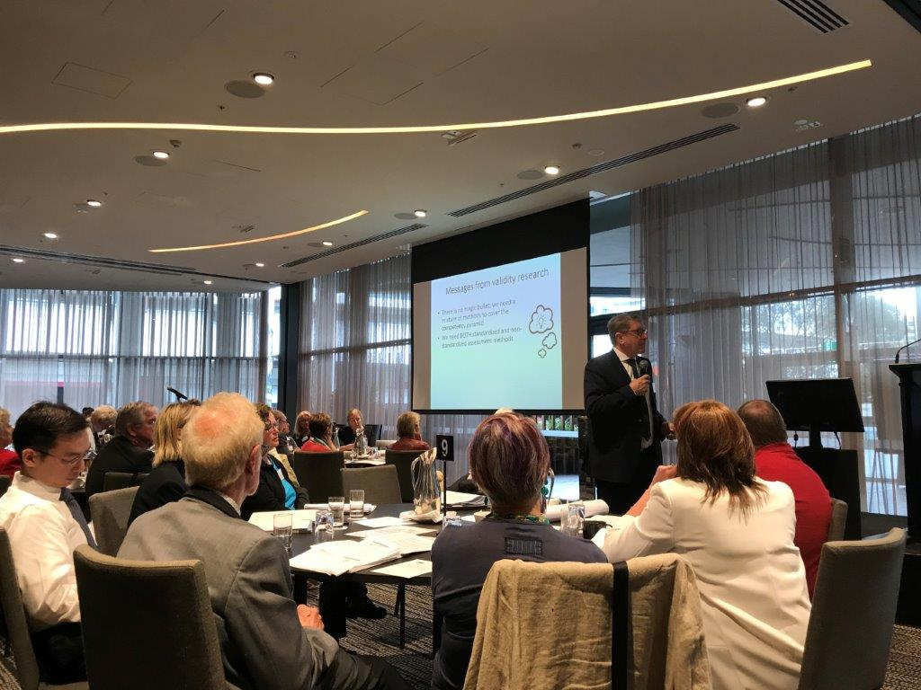

Prof Cees van der Vleuten presenting at the AMC Workshop on Assessment 2017.

Programmatic Assessment and the Medical Continuum –
Prof Cees van der Vleuten

- Current state of Assessment: Medical Education has been dominated by the creation of a wide range of assessment tools. Miller’s pyramid has been particularly influential in helping us to making the transition from fact-oriented assessment to focusing assessment on measuring what doctors actually do.

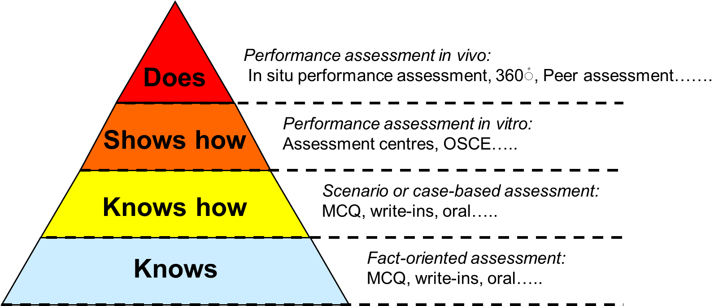

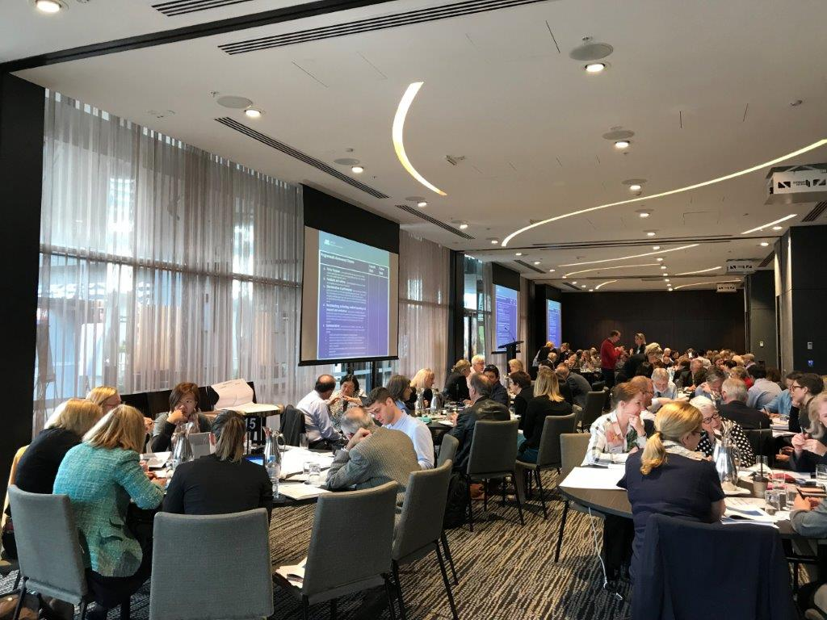

Group discussion at the AMC Workshop on Assessment 2017.

- Instruments for determining the quality of Assessments:

- Validity: Focuses on the question of – what are we assessing. The focus of validity in medical education has changed over time:

    - From time served to outcomes: We have seen a transition from input methods (defining hours and time served in training) to outcomes-based criteria. This has seen a transition from haphazard learning to integrated objectives, to end objectives and now generic competencies. Beyond medicine, this movement has become a feature of school and professional education. Within medicine, there has been a great deal of consensus about what a doctor should do. CanMeds as defined by the Royal College in Canada, has been particularly influential in determining more contemporary ways of defining the work of doctors. This framework has been developed with a lot of stakeholder engagement and consensus about what a doctor should do. CanMeds is based on the premise that most of the competencies move beyond knowledge domains. They are complex skills and behaviours. The validity of this framework is supported through the recognition that 80 percent of consumer complaints can be attributed to communication errors. These competencies develop longitudinally so if we take this seriously we need to assess performance or behaviours at the top of Miler’s pyramid.
    - Teacher oriented to self-directed: There has been a significant shift in theories and methods of learning which have impacted on what and how we assess. This transition has been marked by increased focus on the agency of the learner in determining how and what they need to learn to support them to succeed.
    - Messages from validity research – no single method can do it all. We need a mixture of methods. We need both standardized and non-standardized assessment methods. For standardized assessment the quality control around test development and administration is vital. In non-standardised assessments the utility is provided not in the instrument but in the interaction between humans. The quality of the assessment is provided through the feedback after the encounter – that is the value of the non-standardized. This means that ‘we don’t need to sharpen the instruments. We need to sharpen the people – they need to understand what they are doing and why’.

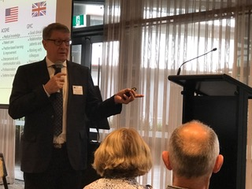
Prof Cees van der Vleuten presenting at the AMC Workshop on Assessment 2017.

- Reliability: Focuses on the question of – how stable is the assessment decision over-time and encounters. Research into the reliability of assessment in medical education has shown:

  - Shorter tests are unreliable. Any sort of performance is contextually bound. As soon as you change the context you change the outcome. Given this, in shorter tests we see that there are a lot of false positives and false negatives based on the noise of the measurement. One single measure is no measure. Research into the method reliability of testing time (Van der Vleuten and Schuwirth 2005) shows that if we assess for long enough (four hours+) we can select any type of assessment as we will gain similar high quality and reliable scores of 0.8+.
  - Sampling. If we wish to assess complex behaviours we need to rely on some form of professional judgement and many of these judgements can build up a pretty robust picture. Sampling allows the assessor to combine information across multiple sources. Research has show that eight observations get a reliable score. There is also the effect of aggregation of score across methods. If we start to combine methods the sample can be even lower.

- Educational Impact: Focuses on the question – how does assessment improve learning and performance. Traditional assessment research has focused on psychometrics so educational impact has not been a concern. The relationship between assessment and learning is complex:
  - Assessment for learning. Assessment clearly drives learning but may not result in long-term retention. There is a lot of reductionism related to grades culture, poor feedback and tick box assessment practices. The most dominant model of assessment is a cram and dump style of learning and assessing whereby 50 percent of what is learnt is not retained after two weeks.
  - Longitudinal assessment. The antidote to such practices is longitudinal assessment, whereby there is a continuous model of assessment throughout training, supported by ongoing constructive feedback.

Programmatic Assessment: At a Glance.

12 Tips | - Develop a master plan
 | 2. Adopt a robust system for collecting information
 | 3. Develop examination regulations that promote feedback orientation
 | 4. Assure that every low-stakes assessment provides meaningful feedback for learning
 | 5. Provide mentoring for learning
 | 6. Ensure trustworthy decision-making
 | 7. Organise intermediate decision-making assessments
 | 8. Encourage and facilitate personalised remediation
 | 9. Monitor and evaluate the learning effect of the program and adapt
 | 10. Use the assessment process information for curriculum evaluation
 | 11. Promote continuous interaction between stakeholders
 | 12. Develop a strategy for implementation.

Discussion
Small groups ~20 minutes
- Consider the key concepts underpinning programmatic assessment.
- Discuss your current state and proposed plans for assessment in your training program.
- Consider where you are at with the design and implementation of programmatic concepts in your training program.
- For those participants who are from a regulatory organisation, jurisdiction, or other key stakeholder of medical education, consider your observations of the current state and desired future state of medical education assessment.
- Record the key points of your group on the posters provided. Refer to pages 25-28 of this workbook for further information about the key criteria.
- Prepare to report back, including where you are at on the scale (see page 24).

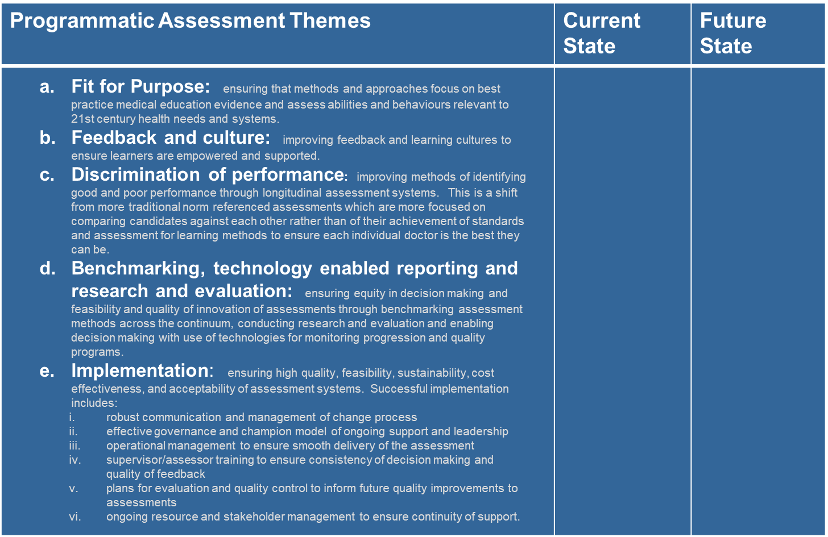

Plenary ~20 minutes
- On a scale of 1-10 (where 1 is not on the radar and 10 is fully implemented and accepted), where are we at in the adoption of programmatic concepts across the medical education continuum?)
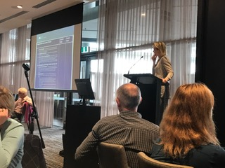

Prof Liz Molloy facilitates the plenary discussion on Programmatic Assessment Across the Medical Continuum.

Not on the radar
Fully implemented & accepted assessment approach
Plenary Summary of Five Themes of Programmatic Assessment

Fit for Purpose

Where we are at across the medical continuum:
- Assessment Mapping. Assessment mapping is being undertaken with clear rubrics to get objective assessments but we have a long way to go.
- Behavioural Markers. Excited about potential use of behavioral markers as structure for feedback process and enabled through technology rather than reliance on paper-based methods.
- Self-evaluation. There is use of technology for students to self-evaluate and then receive external cues and discuss.
- Sustainability. It is vital to think through assessment from a sustainability point of view to ensure that it is doable. GPs are using assessments for multiple purposes and aligned with different outcomes. Trainees do case write ups, then they are asked to produce questions collated into formative assessments. They then identify which questions they find most contentious then they discuss in peer groups and come up with consensus. In this model of assessment trainees learn, gain feedback, critique own assessment and discuss. This forms a community of practice around assessment and feedback thus through consensus building new information is built into the system based on authentic assessment. This assessment practice is aligned with David Boud’s concepts of sustainability of assessment.

Feedback and culture

Where we are at across the medical continuum:
- Feedback. Not doing feedback sufficiently well. Need to focus more on supervisor training – training supervisors to ask trainees and students what they need to improve rather than giving answers or building a culture whereby trainees and students are overly dependent on being told what to do. Through questioning there is an opportunity to build a more empowered and self-accountable trainee workforce.
- Questioning. There are parallels with clinical practice in terms of the effectiveness of clinician communication techniques such as motivational interviewing with patients and improved patient adherence to medication and trainee and medical student feedback approaches which focus on the supervisor asking questions rather than giving answers.
- 360 degree feedback. There is an opportunity to use 360 degree feedback effectively at the beginning and end of training as a diagnostic and evaluation tool.

Progression and discrimination of performance

Some issues:
Where we are at across the medical continuum:
- Pass/Fail Grades. Students don’t see the relevance of grades beyond Pass/Fail because it does not necessarily relate to how good they are as a doctor or how much they know.
- Feedback. More important to focus on providing strong qualitative comments and feedback to strengthen assessment for learning.

Benchmarking, technology enabled reporting and research and evaluation
nchmarking, technology enabled reporting and evaluation/research

Some issues:
Where we are at across the medical continuum:
- Reporting on qualitative data. Technology enables reporting on qualitative data. In the future Artificial Intelligence will further support decision making.
- Behavioural Markers. Excited about potential use of behavioral markers as structure for feedback process and enabled through technology rather than reliance on paper-based methods.

Implementation

Some issues:
- Change management robust communication and management of change process
- Governance and leadership support effective governance and champion model of ongoing support and leadership
- Operational management operational management to ensure smooth delivery of the assessment.

Programmatic Assessment – What Problems are we Solving?
Burning questions and good ideas
The following assessment issues, categorised in five key themes, have been summarised from the literature and observations of problems and issues, which can impact the success of assessments, and more broadly impact the growing of a quality medical workforce.

In this section of the workshop, we added to our list of burning questions and good ideas to work towards avoiding some of the pitfalls of assessment in training programs.

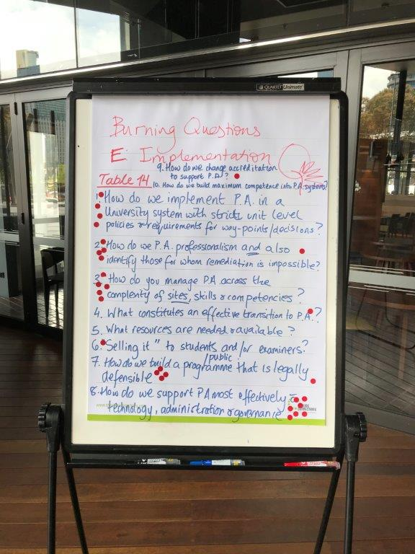

Discussion
Small groups ~15 minutes
- What are your burning questions related to a key theme in assessment?
- What are your good ideas related to a key theme in assessment?
Plenary ~15 minutes
- Review the burning questions and good ideas that other groups have created.
- Using your red dots – select those questions, which you are most keen to hear the experts answer in the next session.
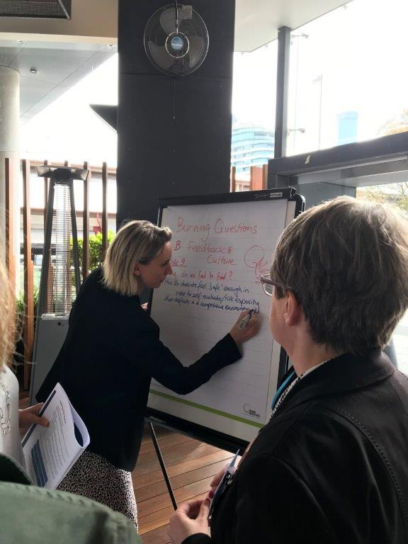

Prof Liz Molloy scribes some burning questions on feedback and culture.

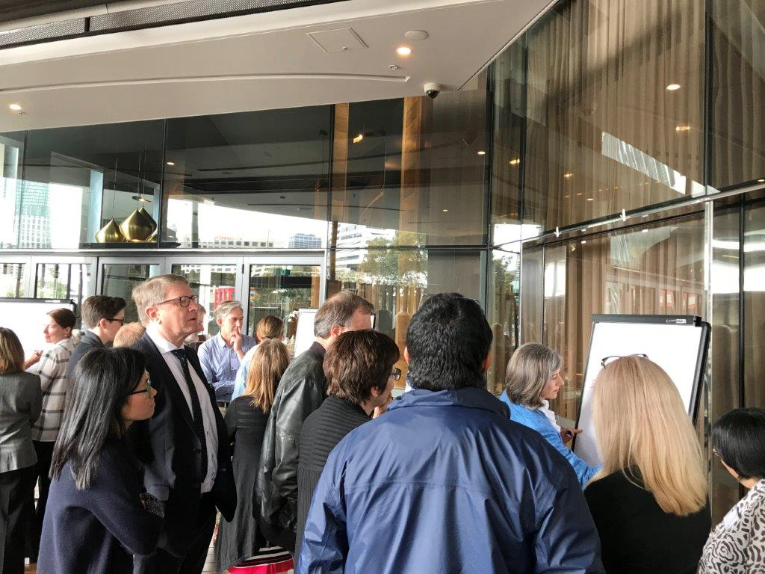

Groups brainstorm burning questions for the experts to answer.

Fit for Purpose

Some issues:
- Patient safety and appropriate assessment load ensure assessments do not compromise patient safety or pose a risk to the wellbeing of doctors
- Assessing important health priorities ensure that the assessment aligns with assessment of health priorities including Indigenous Health and Cultural Competence, Professionalism, Patient-centred care and Inter-professionalism
- Curriculum design and framework reflective of best practice in terms of patient-centred efficient care, not just physiology and pathophysiology (i.e. how to be a good doctor)
- Coverage of the curriculum ensure that the assessment aligns with the curriculum and thus provides transparency about what needs to be learnt
- Assessment of non-observable behaviour emphasise the importance of aspects of the profession that may not be readily observable, such as self-care and ethics
- Assessment for learning achieve a balance between detail and high level concepts and drives good practice in lifelong learning i.e. should not be focused on minutiae or esoteric “factual recall” – “facts” that will be revised / changed in a year or two
- Health system and community needs ensure assessment aligns with community and health system needs

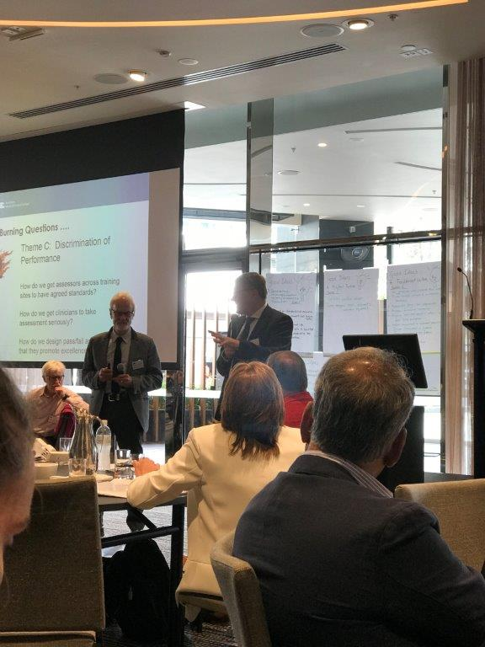

Prof Cees van der Vleuten answering a burning question – Session chaired by Prof David Prideaux.

Burning Questions: Fit For Purpose
1. | How do you define ‘the purpose’ at the beginning of the continuum, e.g. medical school? | OOOOOO
2. | How do you raise awareness of need for change? Or the need to think about it? | OOOOOO
3. | How do we clone Cees?
4. | How to implement with huge numbers? | OOO
5. | How to ensure alignment of assessment types at curriculum? | OOOOO
6. | How can each individual data point be different?

Good Ideas: Fit For Purpose
1. | Portfolio: specified contexts.
2. | Tools: custom designed tools: alignment with curriculum objectives.

Feedback and culture

Some issues:
- Lifelong learning design the assessment program to avoid engendering a tick-box approach to meeting training requirements
- Agency and learner empowerment enabling students to focus on learning and develop skills. The focus of summative assessment needs to be on how learners demonstrate their accountability for their learning in terms of awareness of their own skills, level of performance, current gaps and future learning goals
- Competition assessment systems may drive a hyper-competitive environment between learners and impact the support they provide to each other as peers. We need to ensure that the assessment system supports peer learning
- Wellness assessment may impact the health and wellbeing of doctors. We need to ensure that assessment load is appropriate, non-punitive and free from bullying and harassment
- Burden of assessment the assessment load may be too high – causing too much stress and may be too high stakes without an appropriate balance with lower stakes assessment
- Remediation lack of remediation and negative effects on self-worth and treatment by the broader cohort and culture
- Feedback lack of feedback on exams and performance assessments
- Gifted and talented limited guidance to high performing candidates
- Interprofessionalism the avoidance of siloing of professions
- Quality standards avoid giving the idea that changes to the assessments will result in “dumbing down” the expectations of trainees. If we are embarking on multiple points or work-based assessments and reducing emphasis on high stakes examinations there is a danger that this will be seen as reducing standards?

Burning Questions: Feedback and Culture
1. | What is our risk appetite / can we change? | OOO
2. | Large cohort:  - How do we provide meaningful feedback to all?  - How do we gather, collate and give feedback on multiple points – assessment/supervisors/peers/administrative staff?  - Any IT solutions?  - How big is too big? | OOOOOOOOOOOOOOOO
3. | Busy clinical practice – how do we build culture over pure service provision? How do we make teaching/education/feedback a priority? | OOOOOOOOOOOO
4. | How to create culture where supervisors and registrars are on a learning journey together? | OOOOOOOOO
5. | How do we get learners to seek feedback? | OOOOOOO
7. | Why do we fail to fail? | OOOOOOOOOOOOO
8. | How do students feel ‘safe’ enough in order to self-evaluate/risk exposing their deficits in a competitive environment? | OOOOOOOOOO
9. | How do we tailor feedback to individuals in a timely way (to enable them us use feedback)? | OO
10. | How do we turn the system on its head (? Our risk culture) | OOOO
11. | Why are we still holding on to feedback information (prevents ‘feedforward’)? (Counter to PA.) | OO
12. | How can we prevent burnout of educators/feedback providers? | OOOOOOOOOOO
Good Ideas: Feedback and Culture
1. | Feedback - Ask students what feedback they want; Provide context – purpose of assessment and feedback; patient engagement in feedback; train supervisors to give feedback; specific actionable feedback.
2. | Student engagement in assessment processes.
3. | Transparency.
4. | Appropriate tone: non-judgmental.
5. | Stronger, formalized mentorship.

Progression and discrimination of performance

Some issues:
- Journey mapping clear guidance about how assessments look in a practical sense including the specific assessment tools to be used, the location of decision-making points for aggregated assessment, specific progression decisions and the teaching and learning support students/trainees can access to support their progression including strategies for dealing with the student in difficulty and in need of remediation
- Professional behaviour need to ensure that the assessment of professional behaviours is sufficient to enable or disable progression through training
- Competence and time what happens to time-based requirements?
How long will training be – can it be shorter? Can students/trainees progress earlier than annually? Core and non –core Can we remove ‘core’ and ‘non-core’ references in the competency-based program?
- Required evidence how will we assess EPAs? – What level of evidence is required? Should all EPAs be assessed each year? Who should assess each EPA and “sign” a trainee off at the end of their training?
- High stakes decisions need to be made by combining “multi-point” assessment tasks, as well as examinations
- Excellence should we be assessing and promoting excellence as well as competence? If so, do we need to establish criteria for the assessment of excellence?
- Failure to fail how can we design the assessment program to avoid some of the “failure to fail” pitfalls.

Burning Questions: Discrimination of Performance
1. | What is the experience of standard tolerance and longitudinal assessment?
2. | How to get assessors across training sites to have agreed standards/shared competencies? | OOOOOOOOOOO
3. | What is the best method of determining competence? | OOOO
4. | Are scale ratings a good thing?
5. | How do we get clinicians and hospital administration to take assessment seriously? | OOOOOOOOOOOOOO
6. | Is everything aligned to move from pass/fail?
7. | How do we record and manage the performance data?
8. | Systems value for teaching training feedback? | O
 | (Determination of Performance Standard) | OOO
1. | What are we trying to “discriminate”?
2. | Definition of “performance” i.e. levels, stages?
3. | Focus on individual against standard. | OOOO
4. | Motivation beyond “passing” or “acceptable”:  - ASPIRATIONS beyond passing.  - CULTURE beyond passing. | OOOOOOOOOOOOOOOOOO

Good Ideas: Discrimination of Performance
1. | Feedback: both ways – trainee to organization and organization to trainee; regular face-to-face meetings of organisation and educators with supervisors gathering multiple data points to make global assessment of need for remediation or input.

Benchmarking, technology enabled reporting and evaluation/research

Some issues:
- Technology systems avoid clunky design of online systems which do not record or represent assessment information easily
- Decision Analytics record assessment information in ways that supports decision making and reporting on performance and work readiness
- Sustainability of innovation share assessment items and consider creation of a pool of assessment items for use across Medical Education Providers
- Evaluation plans for evaluation and quality control to inform future quality improvements to assessments
- Research on health impacts and innovation analysis of performance across the system – indicator of candidate comparability and limited writing up of local innovations in assessment
- Evidence-based design reference to evidence on assessment

Burning Questions: Benchmarking, technology enabled reporting and research and evaluation
1. | How to integrate all data into a single reporting form? | O
2. | How can you effectively and efficiently report on qualitative data? | OOOOOOOOOOOOOO
3. | Are there efficiencies across colleges and universities for benchmarking, reporting and research (avoid reinventing the wheel!). | OOOO
1. | Are there any future predictive studies using traditional assessment methods vs programmatic methods. | OOOOO
2. | Improving standards of all vs detecting ‘bad apples’. | OOOOO
3. | Who sets ‘the bar’ with programmatic assessment – the benchmark may be fluid and depend on perspective/culture/societal norms. | OOO
4. | How do we overcome practical constraints in health services to embrace programmatic assessment? | OOOO
Good Ideas: Benchmarking, technology enabled reporting and research and evaluation
1. | Improvements: Agreement to standardised measures to enable quality improvements (not league tables).
2. | Data Systems: capture assessment information, quantitative and qualitative data to facilitate learning at individual and organization level – mindful of privacy considerations.

Implementation

Some issues:
- Change management robust communication and management of change process
- Governance and leadership support effective governance and champion model of ongoing support and leadership
- Operational management operational management to ensure smooth delivery of the assessment
- Supervisor/assessor training supervisor/assessor training to ensure consistency of decision making and quality of feedback and How do we convince supervisors that the “new and different” assessment tools are not enormously time consuming and demanding, but can be incorporated into day to day work?
- Stakeholder management ongoing resource and stakeholder management to ensure continuity of support

Burning Questions: Implementation
1. | How do we implement programmatic assessment (PA) in a university system with strict unit level policies and requirements for way-points/decisions? | OOOO
2. | How do we assess professionalism in PA and also identify those for whom remediation is impossible? | OOOOO
3. | How do you manage PA across the complexity of sites, skills and competencies? | OOOOO
4. | What constitutes an effective transition to PA? | O
5. | What resources are needed and available?
6. | How do we “Sell it” to students/public and/or examiners? | OO
7. | How do we build a programme that is legally defensible? | OOOOO
8. | How do we support PA most effectively with technology, administration and governance? | OOOOOOOO
9. | How do we change accreditation to support PA? | O
10. | How do we build maximum competence into PA systems? | -
1. | How do you train assessors (100’s) over multiple sites? | OOOOOOOOOOOO
2. | How do you educate students about assessment and reflections and action plans? | OOOOOOOO
3. | How can PA be matched with a body focused on licensing? | -
4. | How do you get a platform (e-portfolio) for collection of information (quality and quantity). What do you do with the information? | O
5. | How do you evaluate the PA? | OOOOOOOOOO

Good Ideas: Implementation
1. | Assessors: Funded training of assessors (theory/evidence based, practical); protected time for assessors;
2. | Feedback: Training students/trainees to receive feedback
3. | Training: Better use of resources – shared training; Strong support from the training administration body
4. | Outcomes: Longitudinal study of final outcome: medical school – practice – co-operation between universities – health service – specialist colleges.
5. | Quality: quality leadership driving quality training and assessment.

Presentation: Professor Lambert Schuwirth

~30 minutes

What problems does programmatic assessment solve?

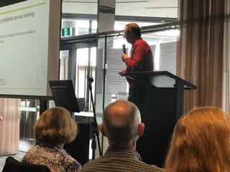
Prof Lambert Schuwirth presenting – What Problems are we Solving?

Programmatic Assessment – What Problems are we solving?
Prof Lambert Schuwirth

Focus on Implementation
Case Studies on Implementation of Programmatic Assessment |  |  | ~80 minutes
Case study participants reflect on:
- What are some smart design principles in this case study?
- How closely does this model and assessment in the case study align with AMC standards?
- What are some implementation strategies you can use in your own training program?

Case study presenters
 | Professor Cees Van Der Vleuten | Programmatic Assessment in the Netherlands
 | Professor Lambert Schuwirth | Programmatic Assessment Pilots at Flinders University
 | Ms Christine Cook | Programmatic Assessment in GP training
 | Professor Kichu Nair | Programmatic Assessment for IMGs
 | Dr Beth Mulligan
 | Professor Liz Molloy | Programmatic Assessment at Melbourne University

See attached case study booklet for summary.
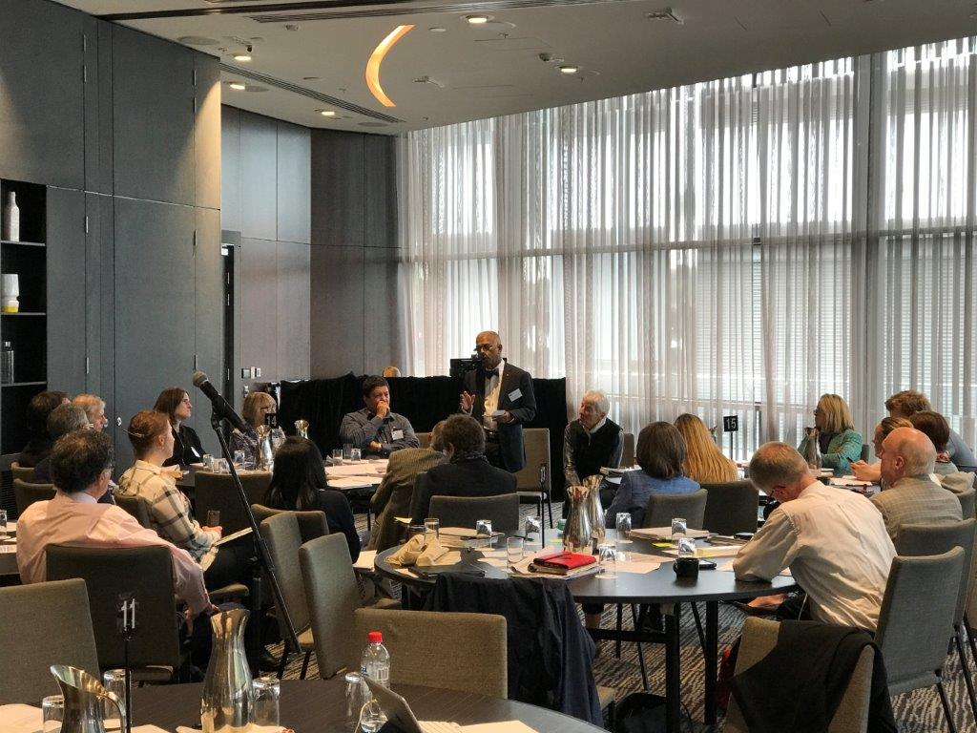

Prof Kichu Nair and Dr Beth Mulligan presenting their case studies.

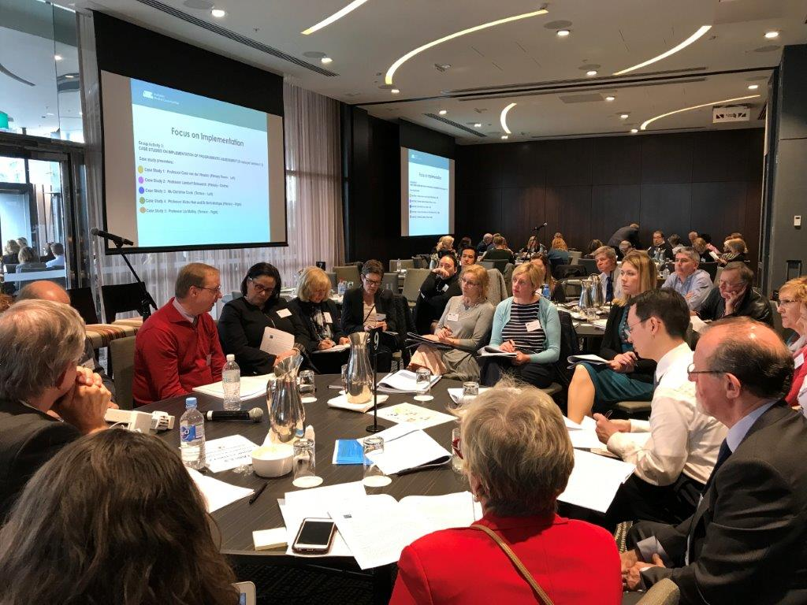

Prof Lambert Schuwirth presenting his case studies.

Top Tips: Implementation of Programmatic Assessment

xxxxx

Where to Next for Assessment?
Panel presentation |  |  | ~30 minutes
Panel members to give a brief update on their thoughts about:
- Next Steps in Medical education Assessment for health; and
- Their ideas about international collaborations about assessment, sharing of best practice and AMC assessment standards review.

Panel members
 | Prof Cees Van Der Vleuten | A lot has happened in Australia in Medical Education in the last few years – we have a real chance…
 | Prof Lambert Schuwirth | The most important thing is that we have people from across the whole medical continuum in the one room. The only way to move forward is for everyone to work together and exchange experiences – all have different contexts and need own design approaches. In Belgium there is a famous seafood restaurant – one enters through the kitchen. Let’s all be like that – encourage others to enter through the kitchen and learn from our mistakes…
 | Professor David Prideaux | I have used this metaphor before of Programmatic Assessment being like a Family photo album, which has studio portraits combined with some less good quality snapshots. Regardless of the differences in quality of the individual snapshots we judge it overall as an album. Studio portraits – high stakes exams - do have a place in programmatic assessment just as part of the picture. To use another metaphor of the iceberg underneath that is the culture of feedback, mentoring and engagement that is critical. Implementation issues are tricky we have to think about all the stakeholders and how they might be part of it.  Take home messages a lot more to programmatic assessment than combining methods – it is a culture. Implementation – have to think about engagement of stakeholders.
 | Professor Liz Farmer | The future, one really important thing – this is a brave new world and new way of doing things. AMC standards need to move with the times in partnership with stakeholders, accreditation needs to be in line with the evidence and contemporary practice. Example of where the accreditor is being a thought leader and be part of the team. If standards are responsive to contexts then programmatic assessment should be responsible to the provider and its individual.
 | Ms Christine Cook | Align organization with the change, make sure everyone understands the change and is on board. Perhaps remember to walk through your kitchen yourselves. Culture of your organization will underpin everything you do.
 | Prof Pete Ellis | Came today wondering what the problems were trying to fix. A lot of news (fake or real) about students concern about intern work readiness. AMC survey results in next few weeks. Why not ready – asking a lot more of them. Focusing a lot on professionalism in terms of trying to assess it, perhaps not how we teach it. Professional training as socialization – don’t get socialized unless engaged with person learning with. Students are in these series of things and lost their connection with people. Programmatic assessment is promoting a more meaningful membership of individuals could go some way to addressing these difficulties and could remove them from the perspective there is no HD – always more to learn and need to be self motivated to get there.

Next Steps
- Circulation of a report summarising findings of day including review of key burning questions by working with experts post workshop.
- Opportunity to establish community of practice to work together on assessment innovations across the continuum and develop best practice guides to support assessment innovation.
- Review and updating of AMC standards on Assessment and Notes.

Further Reading
Biggs J. Teaching for Quality Learning at University: What the Student Does. Maidenhead UK: Open University Press 2003 (2nd ed).
Govaerts MJB, Van de Wiel MWJ, Schuwirth LWT, et al. Workplace-based assessment: raters’ performance theories and constructs. Advances in health sciences education 2013;18:375-96. doi: DOI 10.1007/s10459-012-9376-x.
Harrison CJ, Könings KD, Dannefer EF, et al. Factors Influencing Students’ Receptivity to Formative Feedback Emerging from Different Assessment Cultures. Perspectives on Medical Education 2016;5:276-84.
Heeneman S, Oudkerk Pool A, Schuwirth LWT, et al. The impact of programmatic assessment on student learning – theory versus practice - Medical Education 2015;49(5):487-98.
Schuwirth l, van der Vleuten C. Programmatic assessment: from assessment of learning to assessment for learning. Med Teach 2011;33:478-85.
Schuwirth LWT, Van der Vleuten CPM, Durning SJ. What programmatic assessment for learning in medical education can learn from healthcare. Perspectives on Medical Education 2017:1-5. doi: 10.1007/s40037-017-0345-1.
Schuwirth LWT, Van der Vleuten CPM. Programmatic assessment and Kane’s validity perspective. Medical Education 2012;46(1):38-48. doi: 10.1111/j.1365-2923.2011.04098.x
Schuwirth LWT, Van der Vleuten CPM. Programmatic assessment: from assessment of learning to assessment for learning. Medical Teacher 2011;33(6):478-85.
Van der Vleuten C. The assessment of professional competence: developments, research, and practical implications. Adv Health Sci Educ 1996;1 (1):41-67.
Van der Vleuten CPM, Schuwirth LWT, Driessen EW, et al. A model for programmatic assessment fit for purpose. Medical Teacher 2012;34:205-14. doi: 10.3109/0142159X.2012.652239.
Van der Vleuten CPM, Schuwirth LWT. Assessing professional competence: from methods to programmes. Medical Education 2005;39(3):309-17.

